- First, I store my HTML code and a Dockerfile in a GitHub repository.
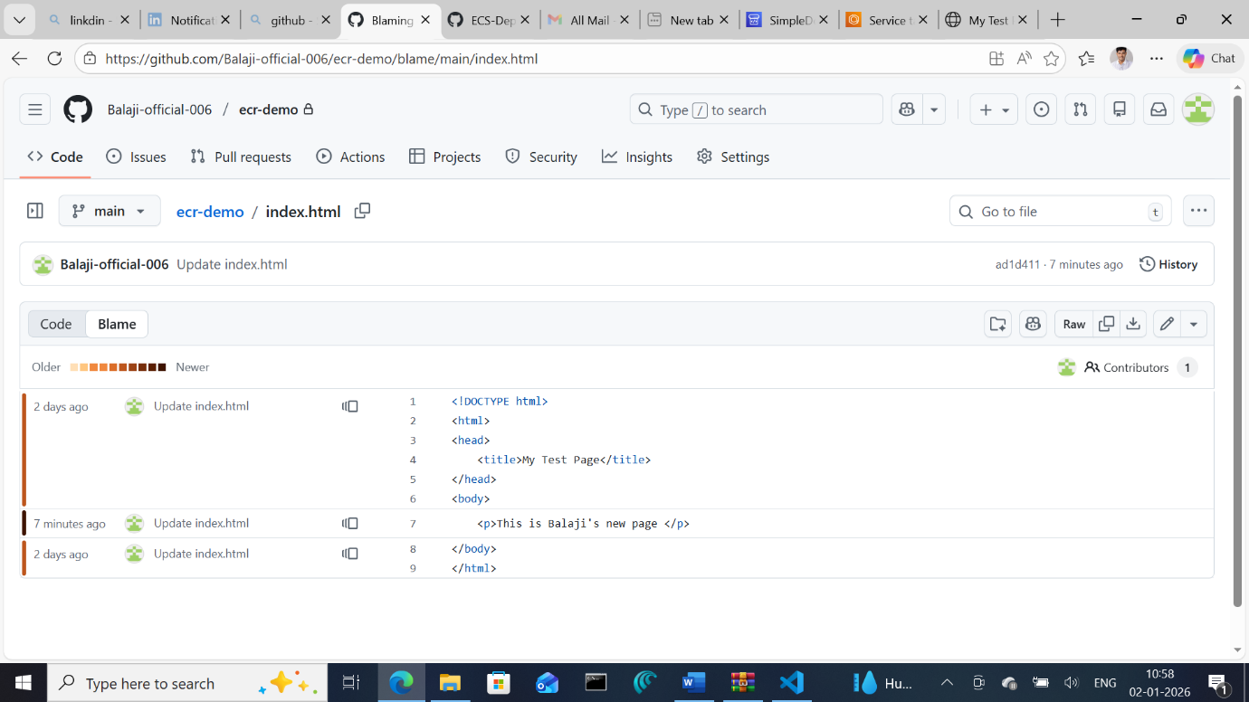
- My Dockerfile uses a multi-stage build: it starts with a Node.js base image to lint the HTML, and then uses an Nginx base image to serve the final result.
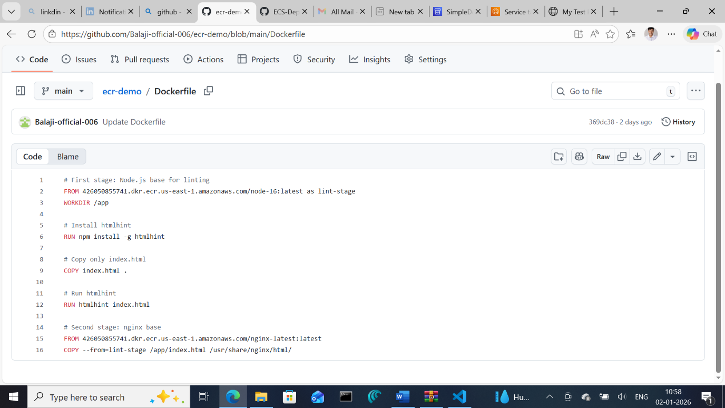

- After building the Docker image, I push it to my ECR repository using the pipeline’s ECR push template.

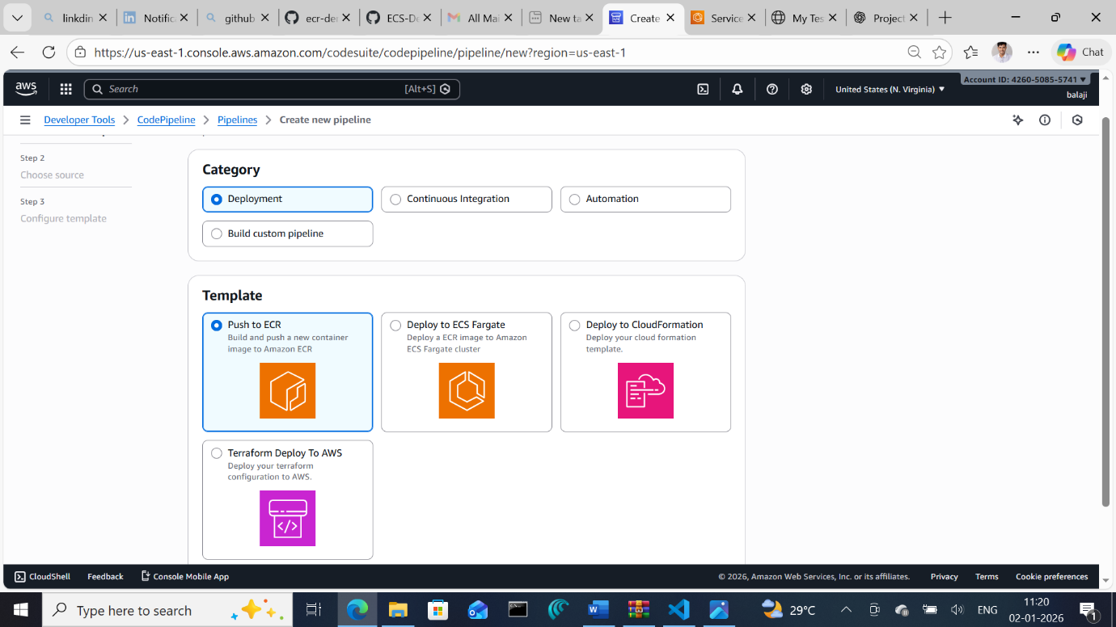
- Here’s the added step: before deploying to ECS, there's a manual approval stage in the pipeline. This means the pipeline pauses and waits for my go-ahead before proceeding.
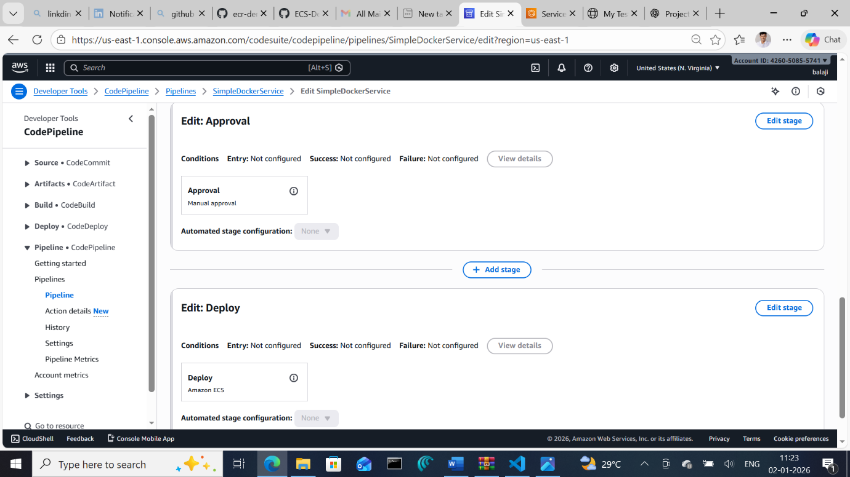

- Once approved, the pipeline reads the imagedefinitions.json from GitHub, pulls the image from ECR, and deploys it to ECS using the specified task definition.

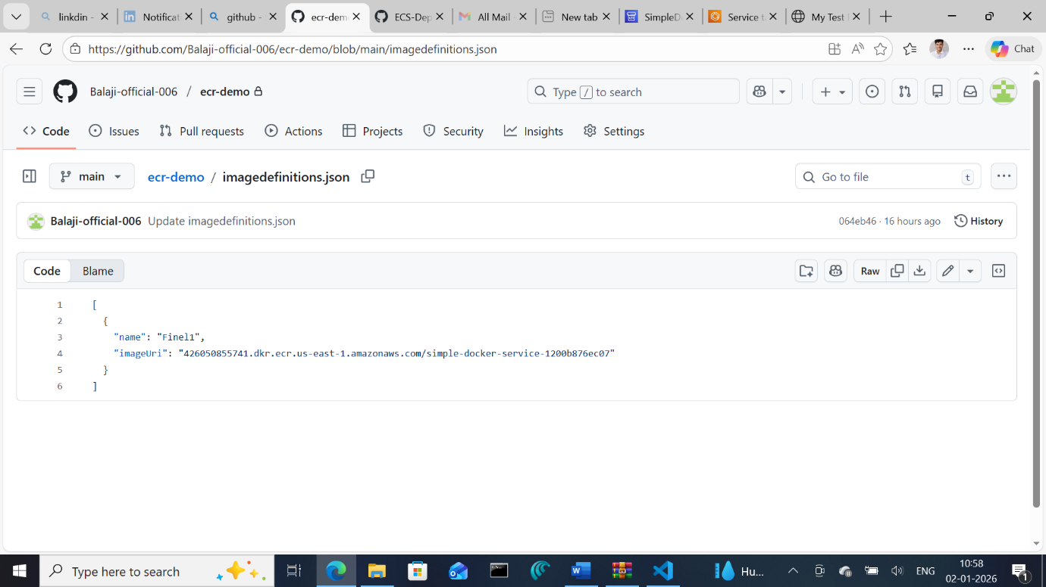
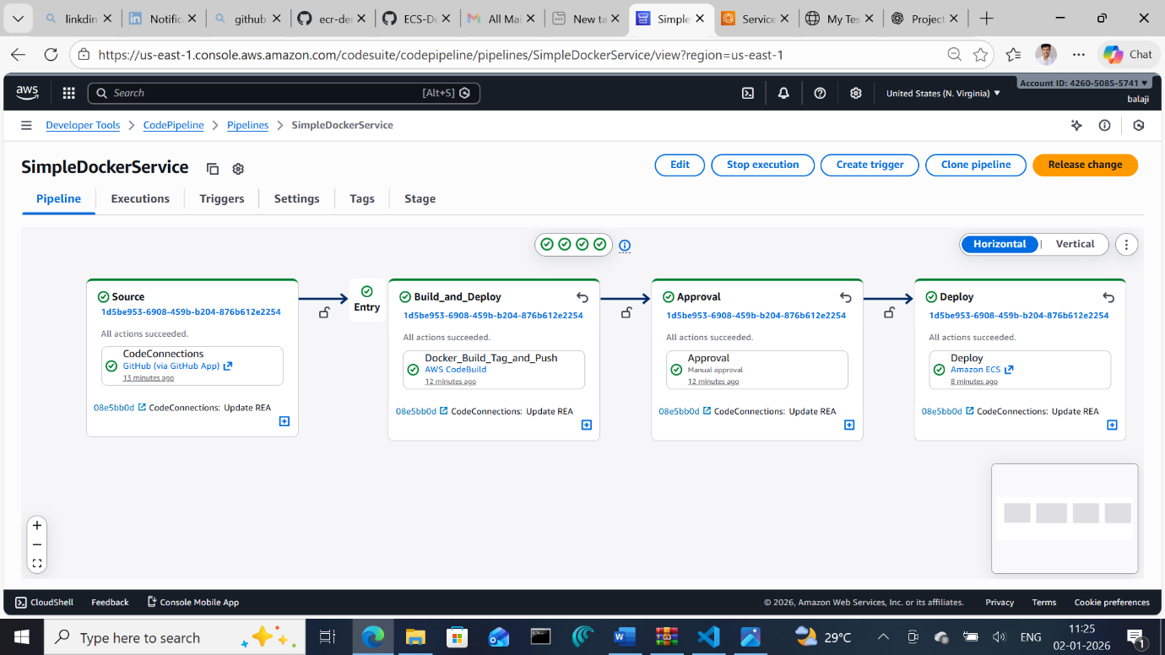

Page Before:
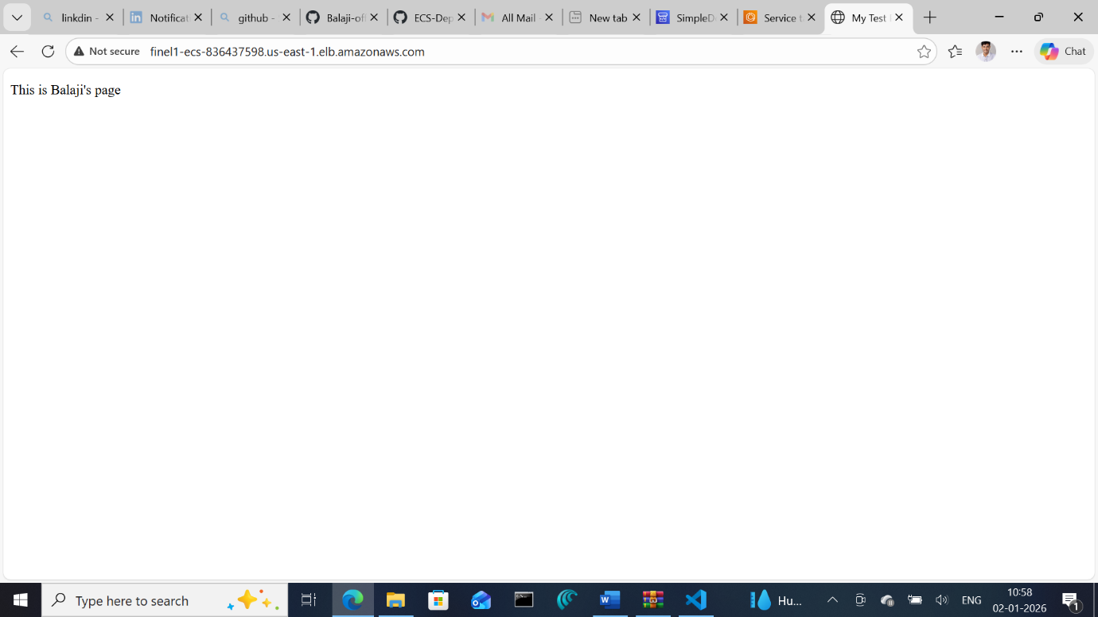

Page After:
